MEMORANDUM

TO: ALL EMPLOYEES

FROM: RUTH CHATMAN
HUMAN RESOURCES DIRECTOR
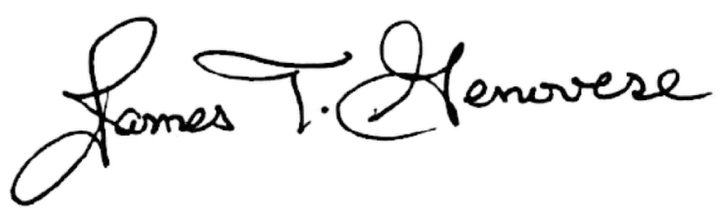
APPROVED BY: JAMES GENOVESE
PRESIDENT

RE: UNIVERSITY HOLIDAYS AND CLOSURES

CALENDAR 2027

DATE: September 15, 2026

The 2027 University Holiday and Closure calendar is attached.

Employees will be required to use annual and/or compensatory leave for any closure listed. For those employees who do not have enough annual and/or compensatory leave and for those employees who do not earn leave, leave without pay must be taken.

Please remember, an employee must be in a paid leave status before and after a holiday day to receive the holiday pay.

THE ALEXANDRIA, LEESVILLE, AND SHREVEPORT CAMPUSES WILL OBSERVE THE SAME HOLIDAYS AND CLOSURES. DEPARTMENTS WITH ESSENTIAL SERVICES WILL BE EXPECTED TO OPERATE AS NEEDED.

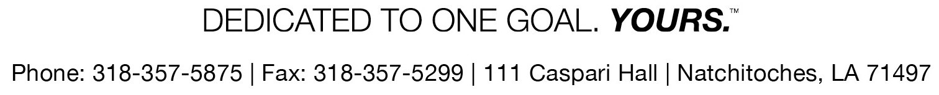

HOLIDAY/CLOSURE | DATE | Holiday  NO Leave  Charged | Closure  Leave  Charged
University Holiday #1 | Friday, January 1, 2027 | X
University Holiday #2 | Monday, January 18, 2027 | X
University Holiday #3 | Monday, February 8, 2027 | X
University Closure #1 | Tuesday, February 9, 2027 |  | X
University Holiday #4 | Friday, March 26, 2027 | X
University Holiday #5 | Monday, May 31, 2027 | X
University Holiday #6 | Friday, June 18 2027 | X
University Holiday #7 | Monday, July 5, 2027 | X
University Holiday #8 | Monday, September 6, 2027 | X
University Closure #2 | Monday, November 22, 2027 |  | X
University Closure #3 | Tuesday, November 23, 2027 |  | X
University Holiday #9 | Wednesday, November 24, 2027 | X
University Holiday #10 | Thursday, November 25, 2027 | X
University Holiday #11 | Friday, November 26, 2027 | X
University Closure #4 | Monday, December 20, 2027 |  | X
University Closure #5 | Tuesday, December 21, 2027 |  | X
University Closure #6 | Wednesday, December 22, 2027 |  | X
University Closure #7 | Thursday, December 23, 2027 |  | X
University Holiday #12 | Friday, December 24, 2027 | X
University Holiday #13 | Monday, December 27, 2027 | X
University Closure #8 | Tuesday, December 28, 2027 |  | X
University Closure #9 | Wednesday, December 29, 2027 |  | X
University Closure #10 | Thursday, December 30, 2027 |  | X
University Holiday #14 | Friday, December 31, 2027 | X
 | TOTAL | 14 | 10
NOTE: According to LA Revised Statute 1:55(F), each institution of higher education in the state, through a representative appointed by it, shall designate a maximum of fourteen legal holidays per calendar year to be observed by all its employees.
NOTE: According to Civil Service Rule 17.10, agencies may require employees to take annual leave, not to exceed a maximum of ten per calendar year, when the efficiency of the agency operations dictates a temporary closure.

