Parental Leave Policy

Effective: 1/1/2024 1. Policy Statement
Parental leave provides the employee time to bond with a child following the birth of a child or placement of a child under the age of 18 with the employee for adoption or foster care. Parental leave also allows adoptive and foster parents to attend post-placement court proceedings and mandatory meetings related to the placement.

Purpose of Policy
Northwestern State University (NSU) will provide up to 240 hours of paid parental leave without deduction to eligible employee’s annual, sick, or compensatory leave balances. Such leave shall be for a qualifying purpose related to an employee’s child born or placed with the employee for adoption or foster care.

Eligibility
- Employee must be in a leave-earning position on the date of the qualifying event;
- Employee must have been employed by Northwestern State University, one of its member institutions, or another state agency for at least 12 months and worked at least 1250 hours in the 12 months preceding the parental leave request;
- Employee must be the legal parent, adoptive parent, or foster parent of the child for whom parental leave is taken when said parent has an active and ongoing role in parenting the child and is taking leave for one of the qualifying purposes set forth below.

Definitions
Legal Parent - a person having a genetic relationship to the child or filiated to the child through legal presumption or assisted reproductive technology.

Policy Procedure
Qualifying events:
- Birth of a child;
- Placement of a child under the age of 18 with the employee for adoption;
- Placement of a child under the age of 18 with the employee for foster care.
Qualifying Purposes:
- For a legal, adoptive, or foster parent to bond with the child for whom leave is taken.
- A need to bond with the child exists when there is a new relationship between the parent and child and the employee will spend time with the child to create an ongoing mutual attachment. This rule is not intended to apply where a relationship resembling parent-child already exists and the primary change is the legal nature of the relationship. (Examples: foster parent to adoptive parent; some intrafamily adoptions such as adoptions by step-parents.)
- For adoptive or foster parents to attend post-placement court proceedings or mandatory meetings related to adoption or foster placement.
Duration:
- Parental leave is available for use only during the 12 weeks (84 calendar days) immediately following the commencement of the qualifying event;
- Parental leave is available for use commencing on the first date of a qualifying event and for only as much of the parental leave period as the employee is engaged in a qualifying purpose;
- Parental leave may be used continuously or intermittently, in accordance with the need therefor;
- Unless the Appointing Authority determines that an employee is utilizing parental leave in violation
of this rule, the Appointing Authority shall not reduce the parental leave period authorized herein nor interfere with the employee’s use of parental leave as set forth herein.
Compensation:
- Full-time employees shall be compensated at the rate of 100% of the employee’s base pay for a period not to exceed 240 hours during the available 12-week period;
- Part-time employees shall be compensated at the rate of 100% of the employee’s base pay for a period not to exceed 6 weeks based upon the employee’s average number of hours worked in the 6 months immediately preceding the commencement of parental leave. (Example: if an employee works an average of 25 hours per week during the 6 month look-back period, the employee shall be paid their base pay for 25 hours per week for 6 weeks).
Limitations:
- Parental leave shall not be donated to another employee or leave pool;
- Unused parental leave shall not be reserved for use during a subsequent qualifying event nor paid to the employee;
- This rule is not intended to provide any form of unpaid leave after exhaustion of 240 hours (or the appropriate allotment for part-time employees) of paid parental leave. Additional leave, if any, shall be taken under the provisions of another rule, law, or policy;
- At least 12 months shall elapse from the beginning of one parental leave period until an employee is eligible for another parental leave period. For a new parental leave period, there shall be a new qualifying event on or after the 12-month waiting period and the eligibility requirements of section
(#3 – Eligibility) shall be satisfied as of the date of the new qualifying event;
- Eligible employees utilizing parental leave for occurrences also qualifying under the Family and Medical Leave Act (“FMLA”) shall use FMLA leave concurrently with parental leave;
- When both parents to the child for whom parental leave is taken are employed, each is entitled to utilize a full 240-hour (or the appropriate allotment for part-time employees) parental leave period.
- In using parental leave, employee shall follow their institution’s customary leave practices. That is, as practicable, advance notice of leave needs shall be provided and leave approved prior to use;
- An employee’s use of parental leave in accordance with this rule and institution policy shall not have a negative impact upon their employment relationship. Employees not utilizing parental leave in accordance with this rule and/or institution policy may be disciplined, including the possibility of separation or dismissal.

Establishing Eligibility for Parental Leave:
- Prior to granting parental leave, a requesting employee must complete a request form from the Department of Human Resources.
- In addition to the request form, an Appointing Authority may require an employee requesting paid parental leave to produce acceptable proof in support of their request, such as a birth certificate or insurance certificate confirming their relationship to the child for whom parental leave is requested or proof of attendance at court proceedings or other mandated meetings related to adoption or foster placement. An Appointing Authority shall not require that an employee produce medical records or scientific evidence to prove paternity.

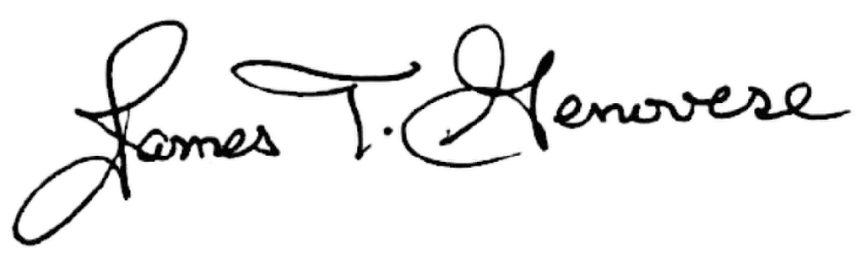
_______________________________
Appointing Authority

NSU Parental Leave Policy Page 2 of 2

